Name: HUN Ravit

ID: e20180328

1. Distinguish between data rate and signal rate:

* Data rate: used to defines the number of data element send in 1s. if we increase the data rate our speed of transmission is increase the same.
* Signal rate: is the number of signal element send in 1s. If we increase the data signal rate the bandwidth requirement is increase the same.

1. Parallel transmission:

* Advantage of Parallel:
  + It offers fast data communication between devices compare to serial interface.
  + High Speed
  + Match to underlying hardware
  + Data is sent much faster as parallel transmission can increase the transfer speed by a factor of n over the serial transmission.
  + A huge amount of data is to be transmitted over connection lines
  + Parallel transmission can send information from computer to printer.
* Disadvantage of Parallel:
  + Expensive
  + Limited shorter distances
  + transmission of n communication lines is requires to transmit the data stream and for this n number of wires mush be require
  + It uses more wires compare to serial interface and hence it is costly and a bit complex to implement.

Serial transmission:

* Advantage of Serial:
  + It uses less number of conducting wires, hence reduces cost of the interface.
  + It supports long distance data communication.
  + It uses less number of wires often only one, this leads to simple interface between transmitting and receiving devices or ICs. It is easy to implement.
* Disadvantage of Serial:
  + It uses less number of lines for transmission between devices. Hence it supports slower speed of transmission.
  + It occupies overhead of about 20% other than useful information. This leads to wastage of bandwidth meant for data trasmission for useless stuff.

Differences between parallel and serial transmission is:

* Bit transaction
  + Serial transmission only one bit at one clock.
  + Parallel transmission eight bits at one clock pulse.
* Cost Efficient:
  + Serial: low cost requires
  + Parallel: more cost requires
* Performance
  + Serial lower than Parallel transmission (single and eight bits)
* Preference
  + Serial: long distance
  + Parallel: short distance
* Complexity
  + Serial less complex than Parallel transmission (single link and multiple link)

1. 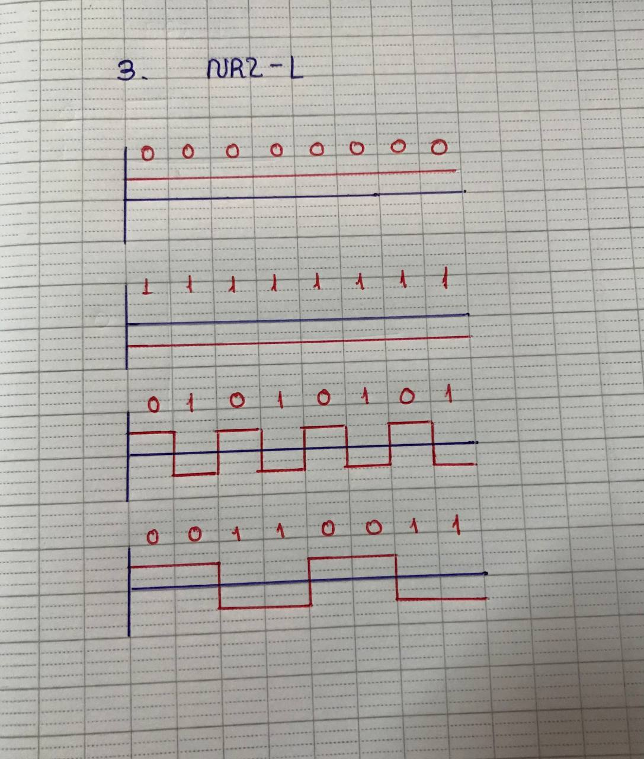NRZ-L schema